Smith, Charles David Roger (Roger) (from Australian Feral Camel Committee and Plant Health Australia websites)

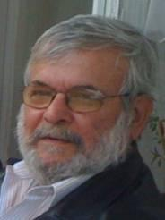

Holds a BSc in Forestry (Honours) ANU 1968, Graduate Diploma in Public Sector Management and is a Fellow of the Australian Institute of Company Directors.
Chair of the Australian Feral Camel Management Project Steering Committee and General Manager of the Tiwi Plantations Corporation, a director of Plant Health Australia and Chair of the NT Livestock Exporters’ Association.
Was head of the NT Department of Primary Industry and Fisheries and General Manager Primary Industry of the NT Department of Business, Industry and Resource Development. Also consulted to the Australian Government Department of Agriculture, Forestry and Fisheries on the Australian Biosecurity Strategy (AusBIOSEC), the NT Government Indigenous Economic Development Task Force, and the NT Cattlemen’s Association on various matters.
Currently a consultant and Principal with Kholassey Pty Ltd, a firm that has consulted to government agencies, including for AusBIOSEC and NCRIS. Former Director of Animal Health Australia. Roger has Chaired Primary Industries Health Committee and the Industry–Government Working Group on Honeybee Biosecurity in the Northern Territory, and been the NT representative on PISC. He was a Director on the Board of the Desert Knowledge CRC.

